**Test description**

You are given a startup.html along with some pictures are needed to display on this page. It is built as a recipe builder, with some basic food ingredients being displayed. Use the given code and add functionality to it as follows.

Note: you can change the given HTML and Javascript code as much as you want/need, if you get the desired results!

Ex 1 - **20 points**

When the user clicks on ANY of the existing food pictures, write/complete the Javascript code such that the clicked ingredient is ADDED to the list of ingredients (the Unsorted List HTML element). Your list of ingredients should always increase with one more list item being added for each click of an ingredient.

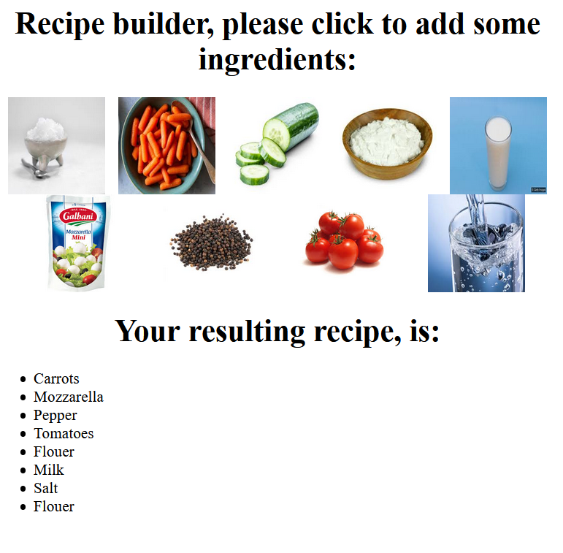

**Note: Duplicate ingredients are inserted into the list! There should be no check AT THIS POINT for duplicate ingredients.**

Ex 2 - **20 points**

Add one button to erase your existing recipe. When the user clicks this button, the already existing recipe should be completely erased.

Ex 3 - **20 points**

Complete your recipe builder and check for duplicate ingredients. Your code should check whether an ingredient has been previously added into the recipe and when this is the case, it should increase the already existing ingredients. An array of items, arrIngredients have been added to this purpose in the startup code. Your result should allow to build recipes like the following:

